NAME: KARTHIGA G SLOT: A
REG NO:192421383 SUB: CLOUD COMPUTING
5. LIBRARY BOOK RESERVATION SYSTEM (SaaS)
AIM
To develop a Library Book Reservation System for SIMATS and deploy it as SaaS using Zoho Creator.
ALGORITHM
- Start
- Login to Zoho Creator
- Create application
- Create library form
- Add book and student details
- Create report
- Run application
- Enter reservation data
- Display reservation details
- Share application link
- Stop
PROCEDURE
- Create application (SIMATSLibraryApp)
- Create form (LibraryReservationForm)
- Add fields: Student Name, Register No, Department, Book Title, Author, Issue Date, Return Date, Email
- Create report (LibraryReport)
- Run application and enter data
- View reservation details in report
- Share application link

OUTPUT SCREENSHOT
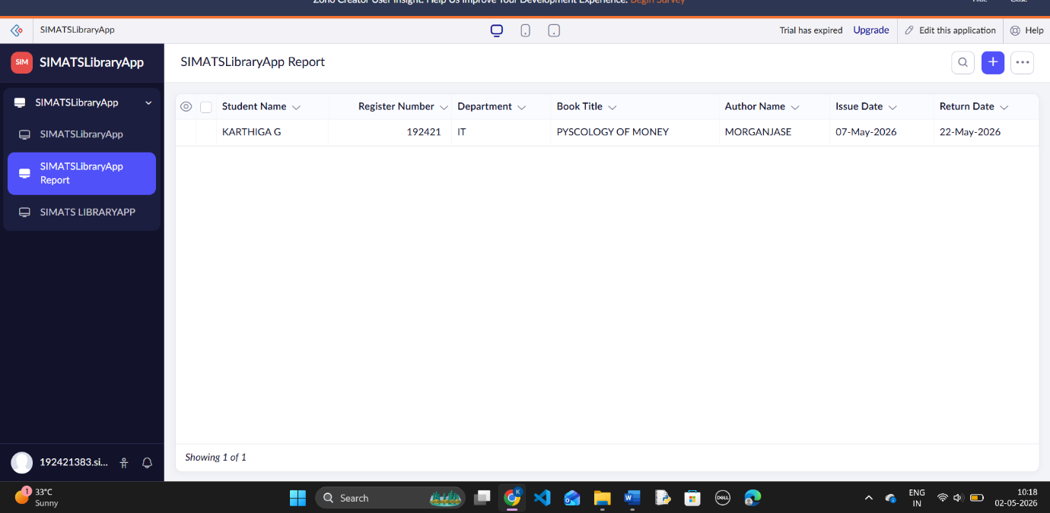
RESULT
A Library Book Reservation System was successfully developed and deployed as SaaS using Zoho Creator.

